**Classroom Activity: To understand the Position property, Pseudo elements, transformation, and transitions.**

**Code: Position Property**

|  |
| --- |
| <!DOCTYPE html>  <html lang="en">  <head>    <meta charset="UTF-8">    <meta name="viewport" content="width=device-width, initial-scale=1.0">    <title>CSS Position Example</title>    <style>      body {        margin: 0;        font-family: Arial, sans-serif;      }      header {        position: fixed;        top: 0;        left: 0;        width: 100%;        background-color: #333;        color: #fff;        text-align: center;        padding: 10px;      }      .sidebar {        position: absolute;        top: 60px; /* Height of the fixed header */        left: 0;        width: 200px;        height: 100%;        background-color: #f4f4f4;        padding: 10px;        box-shadow: 2px 0 5px rgba(0,0,0,0.1);      }      .content {        position: relative;        margin-left: 220px; /* Width of the sidebar + some margin */        padding: 20px;      }      .content h1 {        margin-top: 80px; /* Space for fixed header */      }    </style>  </head>  <body>  <header>    EdunetFoundation  </header>  <div class="sidebar">    <h2>TECHSAKSHAM</h2>    <p>MERN</p>    <p>AI/ML</p>  </div>  <div class="content">    <h1>MERN STACK</h1>    <p>      The now tech-driven job market is that of a dynamic one, whereas the academic infrastructure of the country is not as agile. To enhance the workforce being trained in colleges, to match the skill level demands of the industry is what our work in this domain aims to do. Positioning ourselves to reach the underserved beneficiaries, our work is towards building a relevantly skilled generation of innovators.    </p>    <img src="uma.png">  </div>  </body>  </html> |

**Output:**

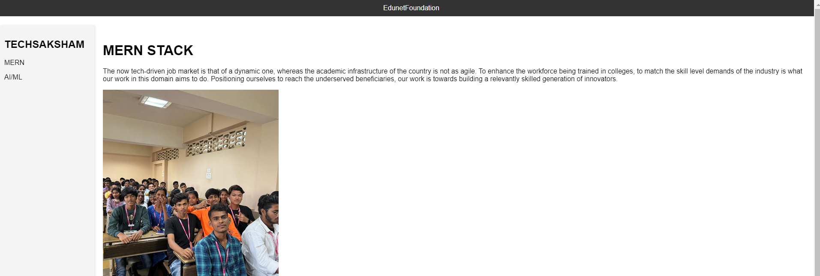

**Code: Pseudo elements**

|  |
| --- |
| <!DOCTYPE html>  <html lang="en">  <head>    <meta charset="UTF-8">    <meta name="viewport" content="width=device-width, initial-scale=1.0">    <title>CSS Pseudo-elements with Emojis</title>    <style>      body {        font-family: Arial, sans-serif;        margin: 20px;      }      ul {        list-style-type: none; /* Remove default list bullets */        padding: 0;      }      li {        padding: 10px 0;        font-size: 18px;        position: relative;      }      /* Add an emoji before each list item */      li::before {        content: '🍎'; /* Default emoji */        position: absolute;        left: -30px;      }      /* Specific emojis for specific list items */      li.fruit::before {        content: '🍇';      }      li.vegetable::before {        content: '🥕';      }      li.dairy::before {        content: '🧀';      }    </style>  </head>  <body>  <h1>Shopping List</h1>  <ul>    <li class="fruit">Apples</li>    <li class="fruit">Grapes</li>    <li class="vegetable">Carrots</li>    <li class="vegetable">Spinach</li>    <li class="dairy">Cheese</li>    <li class="dairy">Milk</li>  </ul>  </body>  </html> |

**Output:**

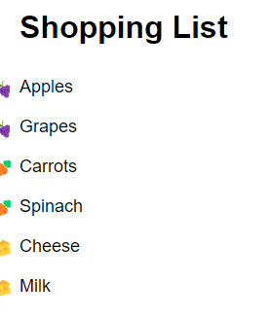

**Code: Transformation**

|  |
| --- |
| <!DOCTYPE html>  <html lang="en">  <head>    <meta charset="UTF-8">    <meta name="viewport" content="width=device-width, initial-scale=1.0">    <title>CSS Transformations Example</title>    <style>      .transform {        width: 100px;        height: 100px;          margin: 20px;      }      .rotate {        transform: rotate(45deg);        background-color: crimson;        border:10px groove white;        color:white;      }      .scale {        transform: scale(1.5);        background-color: crimson;        border:10px groove white;        color:white;      }      .translate {        transform: translateX(50px);        background-color: crimson;        border:10px groove white;        color:white;      }      .skew {        transform: skew(20deg, 10deg);        background-color: crimson;        border:10px groove white;        color:white;      }    </style>  </head>  <body>    <div class="transform rotate">MONGODB</div>    <div class="transform scale">EXPRESS</div>    <div class="transform translate">REACT</div>    <div class="transform skew">NODEJS</div>  </body>  </html> |

**Output:**

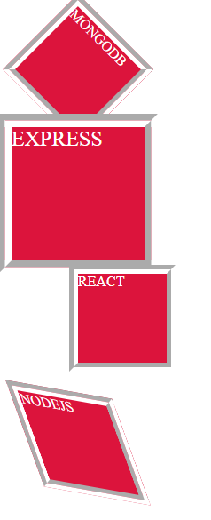

**Code: Transition Functions**

|  |
| --- |
| <!DOCTYPE html>  <html lang="en">  <head>    <meta charset="UTF-8">    <meta name="viewport" content="width=device-width, initial-scale=1.0">    <title>CSS Transition Functions Example</title>    <style>      .box {        width: 100px;        height: 100px;          margin: 20px;        transition-property: transform;        transition-duration: 2s;      }      .ease {        transition-timing-function: ease;        background-color: palevioletred;      }      .linear {        transition-timing-function: linear;        background-color: purple;      }      .ease-in {        transition-timing-function: ease-in;        background-color: teal;      }      .ease-out {        transition-timing-function: ease-out;        background-color: tomato;      }      .ease-in-out {        transition-timing-function: ease-in-out;        background-color: thistle;      }      .cubic-bezier {        transition-timing-function: cubic-bezier(0.68, -0.55, 0.27, 1.55);        background-color:turquoise;      }      .box:hover {        transform: translateX(200px);      }    </style>  </head>  <body>    <div class="box ease">Ease</div>    <div class="box linear">Linear</div>    <div class="box ease-in">Ease-in</div>    <div class="box ease-out">Ease-out</div>    <div class="box ease-in-out">Ease-in-out</div>    <div class="box cubic-bezier">Cubic-bezier</div>  </body>  </html> |

**Output:**



**Execution Steps:**

* Step 1: Set Up Your Project Directory
* Open Visual Studio Code.
* Create a new folder for your project, e.g., PortfolioProject.
* Step 2: Create the file name eg.)property.html
* Write a code for Position property, Pseudo elements, transformation, and transitions.
* Step 3: Click on Go Live.
* Step 4: Then it automatically takes up to the browser page.
* Step 5: Select Inspect
* Step 6: Get the idea of the code.